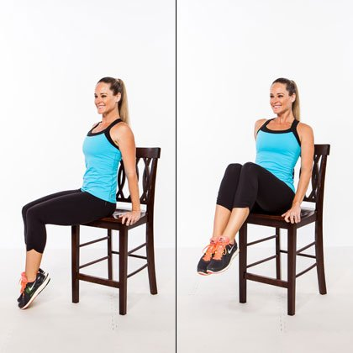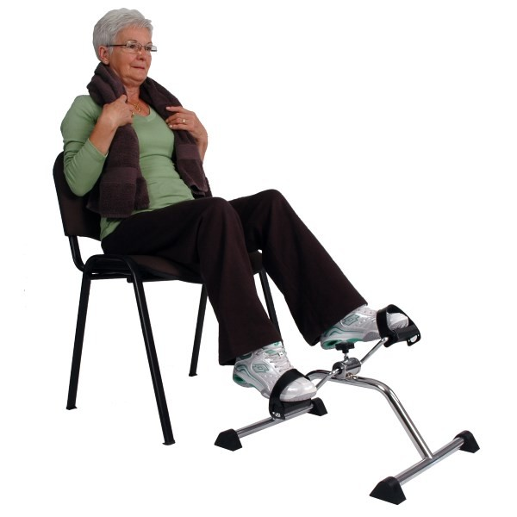**Indoor Biking and Stretching**

**Everyone is welcome!**

Hope Centre Health Care

**Tuesdays Only**

**10 Classes**

**Starting**

**September 19, 2017**

**1:30 p.m. - 2:00 p.m.**

**For more information you can contact Fenella Plett at**

**204-589-8354**