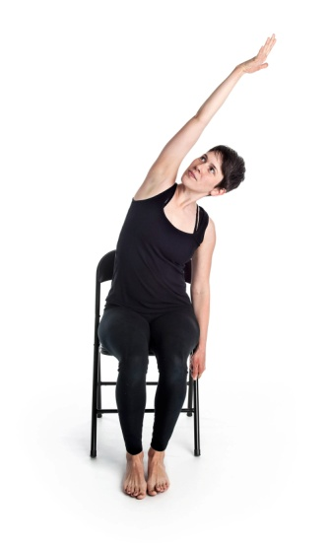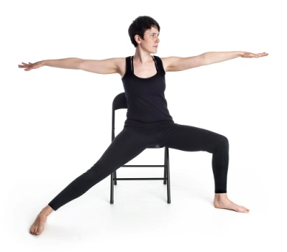

Hope Centre Health Care

**Fridays Only**

**10 Classes**

**Starting**

**September 22, 2017**

**11:00 p.m. – 11:30 p.m.**

**Contact Fenella for more information: 204-589-8354**

