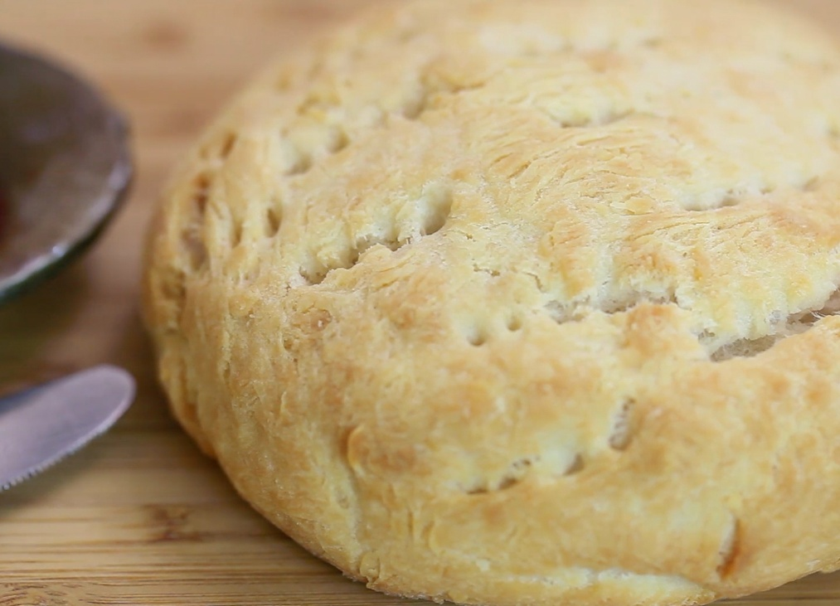Capture.PNG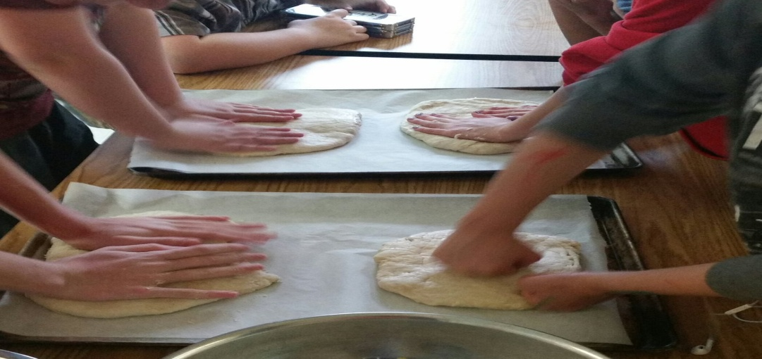Capture.PNG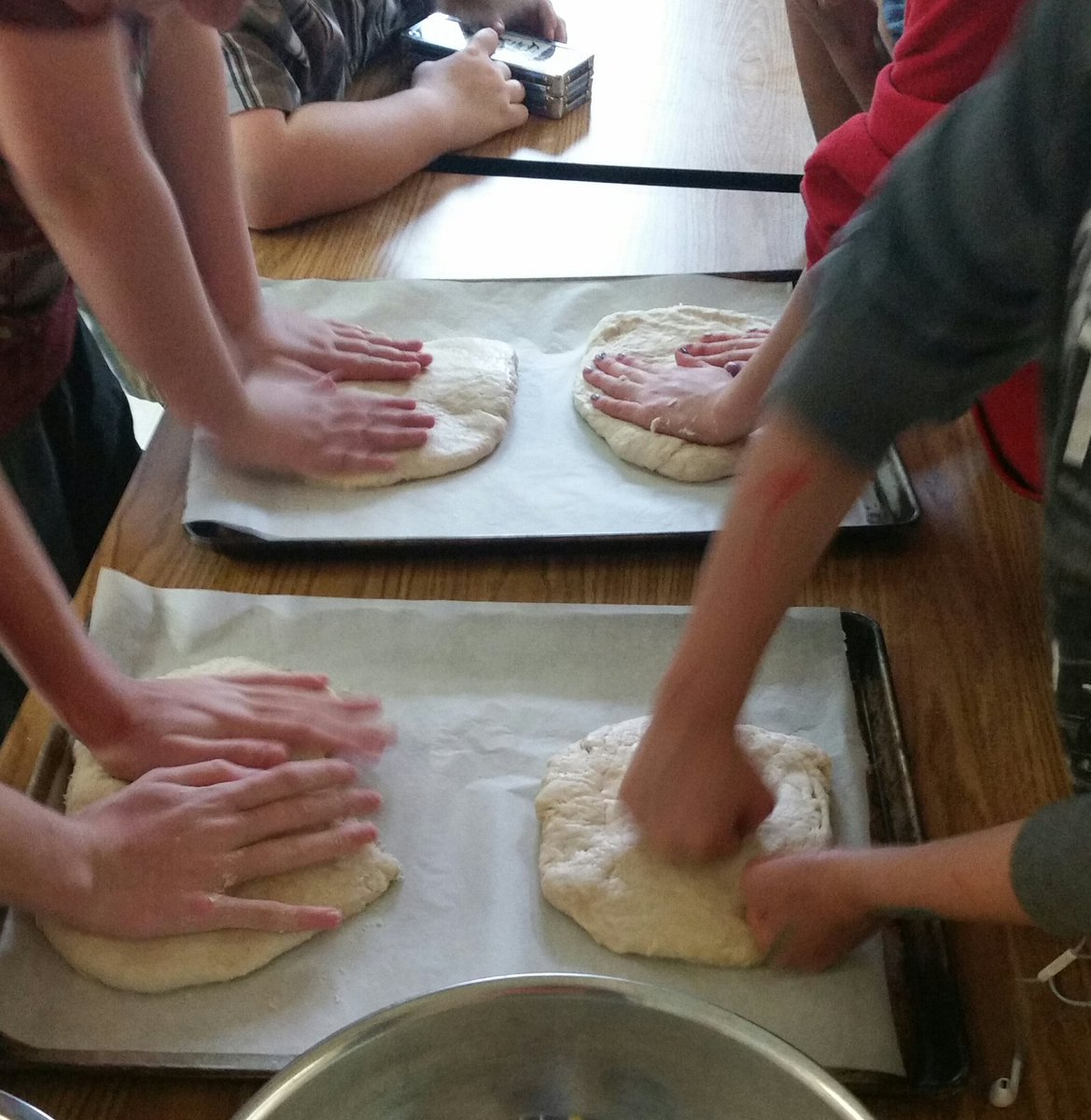

**FREE**

**Tuesdays at Hope Centre Health Care**

**Starting: September 19, 2017**

**9:30 p.m. – 12:00 p.m. &**

**1:00 p.m. – 3:00 p.m.**

**240 Powers Street**

**For more information contact**

**Brenda or Maggie**

**204-589-8354**

**Making**